1. The old icon is still appearing in tab - Done



1. Spelling mistake in manuscript. Correction is (Submit manuscript online) - Done

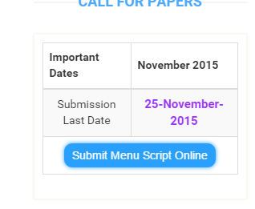

1. When branch name is not selected as other in submit manuscript, it still shows textbox which is supposed to open after others is selected. - Done
2. <http://www.grdjournals.com/author-guideline> the margin between fonts is huge making it look weird. Also make standardization of fonts in entire website. As per our opinion Calibri would be good. Or else you can go with fonts which are appearing in button in picture above. - Changed it to Arial as it is same like calibri and available for all browsers.
3. The pdf files which are opening should be open in new tab. Like if we are clicking on author guidelines in main menu , its opening in self tab.- Done
4. This is source code for creative commons

<a rel="license" href="http://creativecommons.org/licenses/by-nc/4.0/"><img alt="Creative Commons Licence" style="border-width:0" src="https://i.creativecommons.org/l/by-nc/4.0/88x31.png" /></a><br /><span xmlns:dct="http://purl.org/dc/terms/" property="dct:title">Publication</span> by <a xmlns:cc="http://creativecommons.org/ns#" href="www.grdjournals.com" property="cc:attributionName" rel="cc:attributionURL">GRD Journals</a> is licensed under a <a rel="license" href="http://creativecommons.org/licenses/by-nc/4.0/">Creative Commons Attribution-NonCommercial 4.0 International License</a>.

Also note that CC image should be appearing in middle which is not in current website - Changed



1. Change image of open access. - Please provide code like cc.



1. Option name should be “Submit Payment” - Done

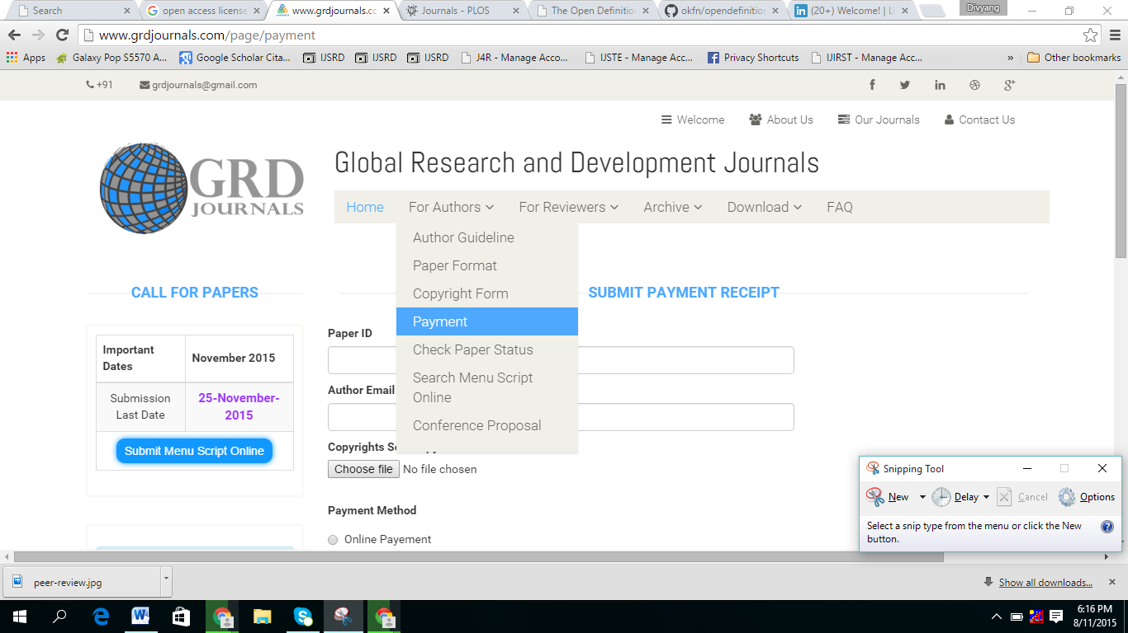

1. <http://www.grdjournals.com/page/confproposal>

here there should be button to submit conference proposal

the fields should be

Name of College/Organization :

Contact Person :

Contact No:

Email :

This also would be available at admin panel.- Done

1. <http://www.grdjournals.com/page/joinboard> changes aren’t reflacted. - Please explain in detail. Did not get what you wanted to say. If possible give me screenshot.
2. <https://www.facebook.com/grdjournals/> integrate our facebook link in icons.- Done
3. <https://twitter.com/grdjournals> integrate twitter.- Done. Make gplus account too. I have added link for that.
4. GRD Journals For Engineering - Done



1. Publication Charges. - Where do you want to display this ?

It should be displaying This.  
GRDJE is offering free publication to all authors for limited period of time. For the limited Duration, GRDJE is costing Rs. 0 as publication charges. So, grab the offer as fast as you can. The paper are accepted under all categories. Submit Your Manuscript NOW!!!